81.12.12b
From Arthur King
RB MSS M1, Library, Royal Botanic Gardens Melbourne.

King & Cunningham  Stock & Station Agents | 67 Bourke Street West.  Melbourne Decr 12th 1881

Baron von Mueller KCMG.

Dear Sir
I sent a flower to you by my gardener yesterday; as he wanted to go for an outing; and I now send a tracing of the bulb from the root end of which the flower stem springs there are 5 or 6 bulbs on the plant I have. I have sent a small parcel containing the leaf which grows from the end of the bulb as indicated. This plant was procured by Lieut Goldfinch of HMS "Emerald" at "Boneta" one of the Solomon Islands and sent to me with several other interesting plants orchids &c the names of which I should be glad to get from you, if you could come over to see me on Saturday afternoon I should be very pleased to see you & to show you my plants.
Yours very truly,
Arthur S King

Many thanks for the book on Papuan plants
The parcel was left at Argus Hotel
Excuse this scrawl for I am writing during business

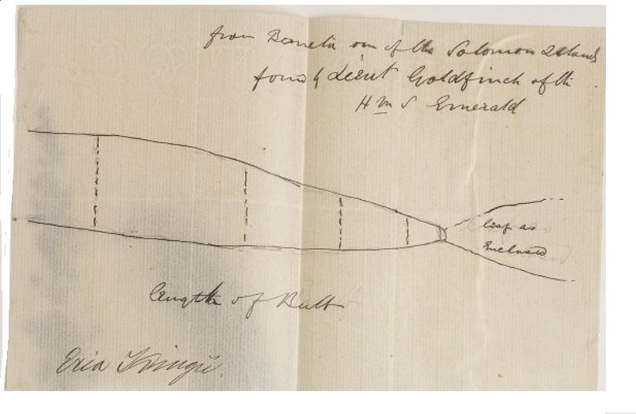

MS found with specimen of Eria kingii (MEL 112566). MS annotation by M: 'Answ 17/12/81'. Letter not found.
Tracing annotated 'Eria Kingii' in M's hand. 81-12-12b_image01.jpg
Banika (i.e. present-day Mbanika)?
B77.02.01 et seq.

